Lab 03: Introduction the DS4 and Functions

# Objectives:

* Introduce functions in C
* Work with the DualShock 4 data

# Starting Point:

* [lab03-1.c](https://drive.google.com/open?id=1aPsNbKrhFJmlLwStBnr6Tsukcod4FpsF)
* [lab03-2.c](https://drive.google.com/open?id=1_unRyZ83kB5m9jtBvGkQSkSkpoBWj-z6)

## About the DualShock 4:

* Each controller has a number on it which matches the number found on the monitor of the computer. The DualShocks can connect through either Bluetooth or USB. The controller should already be paired with the matching computer. You should always use the Bluetooth connection for this class.

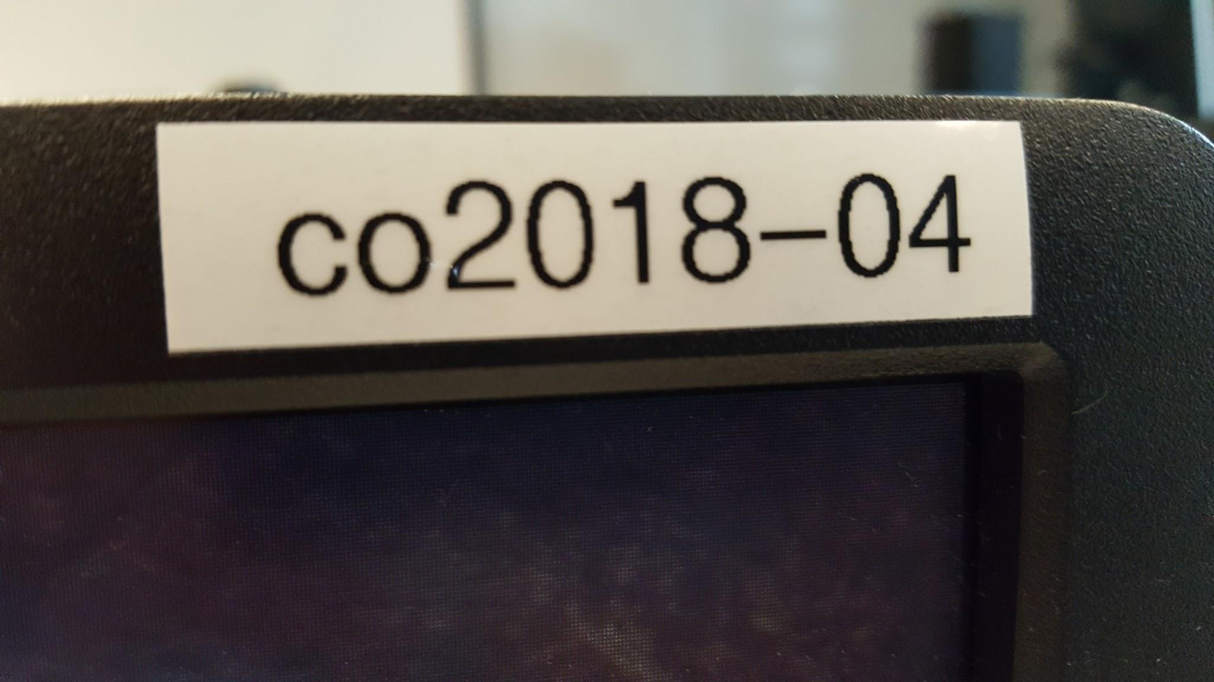

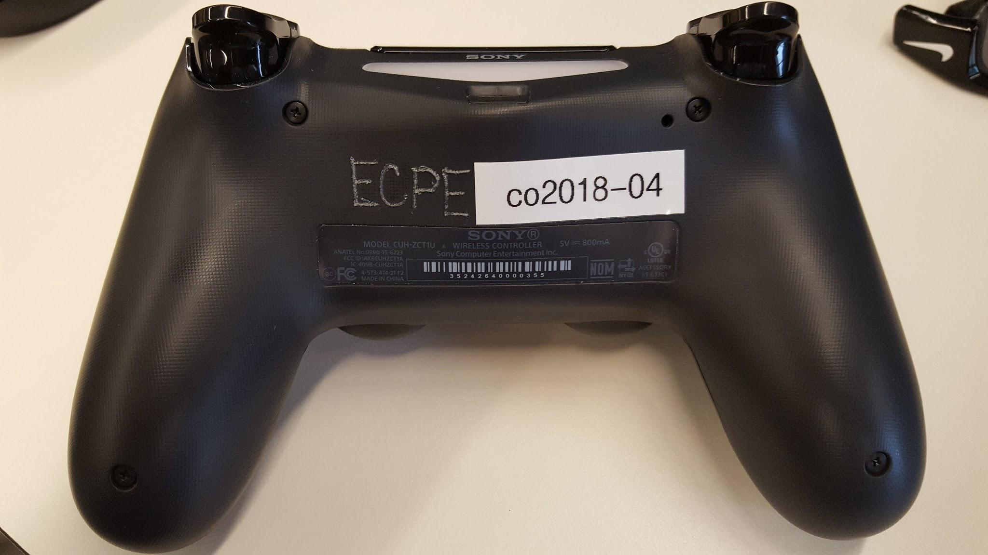

# Turn-In:

Submit a PDF file on Canvas in the standard lab report format by the start of lab next week. Your report should include:

1. 3 Graphs from problem 1.
2. Screenshots of code running from problem 2.
3. Screenshots of code running from problem 3.

If you need help with spreadsheets and creating a scatterplot, **follow the tutorial** available on canvas. You may also ask your undergraduate TA for help.

**Upload one .zip** file of your **lab03** folder. Title this **firstname_lastname_lab03.zip**. Before zipping, delete all generated .exe files (not the **ds4rd.exe**).

# Process:

## Problem 1: DualShock 4 Data Collection

1. Download ds4rd.exe from Canvas to your lab03 folder
2. In Cygwin, making sure you are in your lab3 folder, run ds4rd.exe with the following command:

**./ds4rd.exe -d 054c:05c4 -D DS4_BT -t -g**

1. Move the DS4 around and notice how the values output by the program changes based on the controller orientation and direction. Press ctrl+c to stop the program.
2. Please note the letters after the “**DS4_BT**” parameter. These flags, mentioned in the UNIX Terminal Navigation section of Lab1, determine what kind of data the DS4 will give you. These flags can be combined to return several different types of data.
   1. The -t flag gives time in milliseconds in the output
   2. The -a flag gives the acceleration data in the output
   3. The -g flag gives the gyroscope data in the output
   4. The -j flag gives the joystick data in the output
3. Another point to note is that the “**DS4_BT**” parameter is only used if you are connecting to a computer through Bluetooth. You can also connect the controller to a computer using a microUSB cable. This is useful if you have connectivity issues or the battery in your controller dies. You will need to use “**DS4_USB**” as a parameter instead of “**DS4_BT**”. **Remember to use the correct flag, as the data will not be outputted correctly if the wrong parameter is used.**
   1. Bluetooth Mode with time and gyroscope data:

**./ds4rd.exe -d 054c:05c4 -D DS4_BT -t -g**

* 1. USB Mode with time and gyroscope data:

**./ds4rd.exe -d 054c:05c4 -D DS4_USB -t -g**

1. Collect some data samples (using the redirection of output to a file with **‘>’**)
   1. Place the DualShock 4 flat on the table and run the command below to collect data for roughly 10 seconds. Turn the DualShock 4 over, and while holding the DualShock 4 level do another 10 seconds. You will need to use ctrl+c to stop the program.

**./ds4rd.exe -d 054c:05c4 -D DS4_BT -t -g** **> flat.csv**

* 1. Hold the DualShock 4 such that the light bar is pointing upward and record for 10 seconds, then turn the DualShock 4 over so the light bar is pointing down and continue for another 10 seconds. If you are connected with a microUSB cable, the cable may be slightly in your way.

**./ds4rd.exe -d 054c:05c4 -D DS4_BT -t -g** **> front.csv**

* 1. Choose some simple movement of the DualShock 4 that is easy to reproduce. Collect the data of the movement. Save as **custom.csv**.

**Save these files for your lab report.** You need to use them later for graphs required in the lab report.

1. Open the data in a spreadsheet
2. Create a scatter plot of the 3 right columns (gyroscope values) on the y-axis against the left column (time) on the x-axis. You will have 3 graphs (1 each for flat, front, and custom). The scatter plot should look something like below:

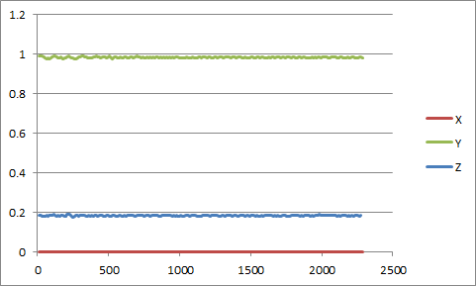

## Problem 2: Introduction to Functions and the DualShock 4

1. Download lab03-1.c to your lab03 folder
2. Compile lab03-1.c to lab03-1.exe
3. Run the following command:

**./ds4rd.exe -d 054c:05c4 -D DS4_BT -t -a | ./lab03-1**

1. Modify the line in SECTION 0 so that the milliseconds are printed out as **SECONDS** as a real number in an **8 character area with 3 decimal digits precision**.

Also modify the line so **acceleration values are shown in a 7 character area with 4 digits of precision**.

1. Uncomment the line of code in SECTION 1, notice the use of the function called magnitude. Uncomment and modify the line of code found in the function magnitude so that the function magnitude returns $\sqrt{x^{2 }+y^{2}+z^{2}}$ (i.e. the magnitude of acceleration).

* Notice that magnitude takes 3 arguments of the double type, and returns a double type.

1. Compile and test the code to make sure magnitude is working correctly.
2. Uncomment the code in SECTION 2. The line(s) of code make calls to three new functions minutes, seconds, millisecondswhich you will implement.
3. For example, if t is 129313 (ms), minutes will return 2, seconds will return 9, millisecondswill return 313. The printf statement uses these functions to output the time as 2 minutes, 9 seconds, 313 milliseconds.
4. Write these three new functions and test your program for correctness**.**

**Grab a screenshot of your program running correctly for you lab report**

## Problem 3: Counting Buttons

1. Download and open lab03-2.c
2. For this problem you will write a program which will output the number of buttons being pressed on the DualShock 4.

Run: **./ds4rd.exe -d 054c:05c4 -D DS4_BT -b**

1. Observe how the output changes as buttons are pressed on the controller.
2. Scan in values similar to problem 1, notice that the values are integers.
3. Write a function which returns the number of buttons being pressed (for example, if TRIANGLE and SQUARE are pressed, return 2). Print out the value returned from this function in the while loop.
4. You may need a line fflush(stdout); after your printf statement. Your TA should have explained this at the beginning of lab.

**Grab a screenshot of your program running correctly for you lab report**

## Ending the Lab Session

1. Be sure you will be able to have access to your code and data when you work on your lab report.
2. Leave your source code on your U: drive.
3. Be sure to place the DS4 on the **charging cradle and put back any cables used**. **Like seriously. Charge them. Do it.**
4. Log off before leaving your workstation in the lab!